VIEW MY PAGE
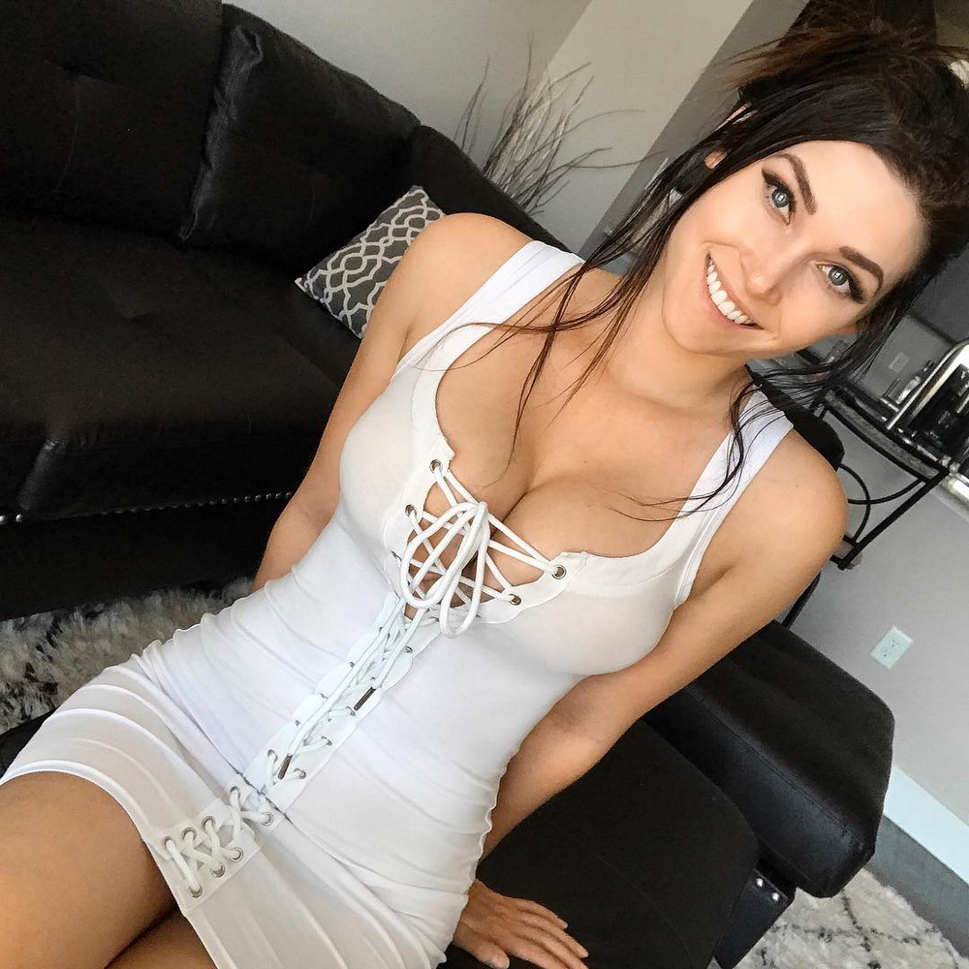

unsubscribe-https://myoffnet.work/uns/

