ENTER ME
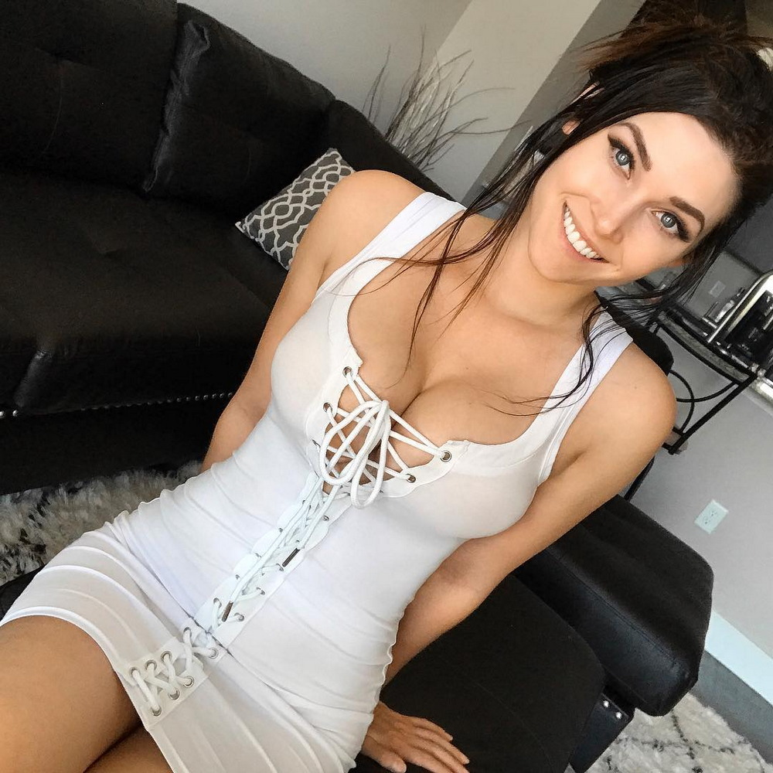

unsubscribe-https://vestildas.work/uns/

