CHAT ME NOW
My nick: velvetaboobs21
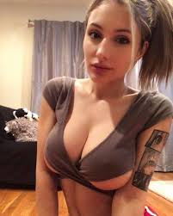

unsub

