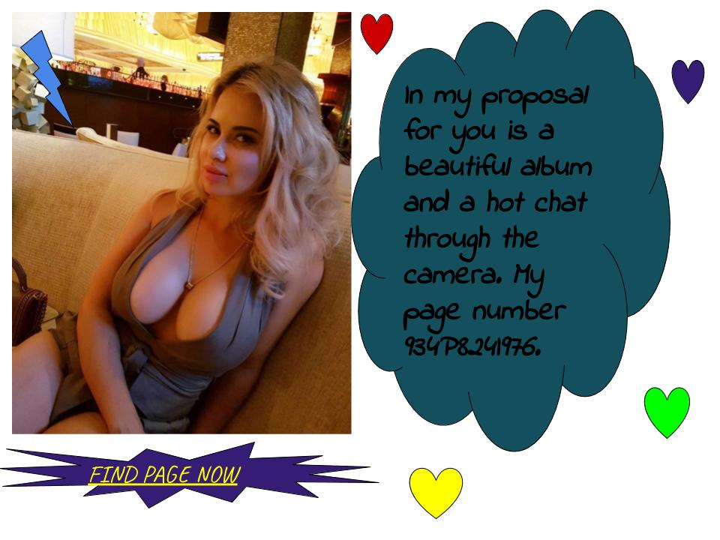
OPEN PAGE HERE

unsubscribe

