My id 109388410938
OPEN MY PAGE
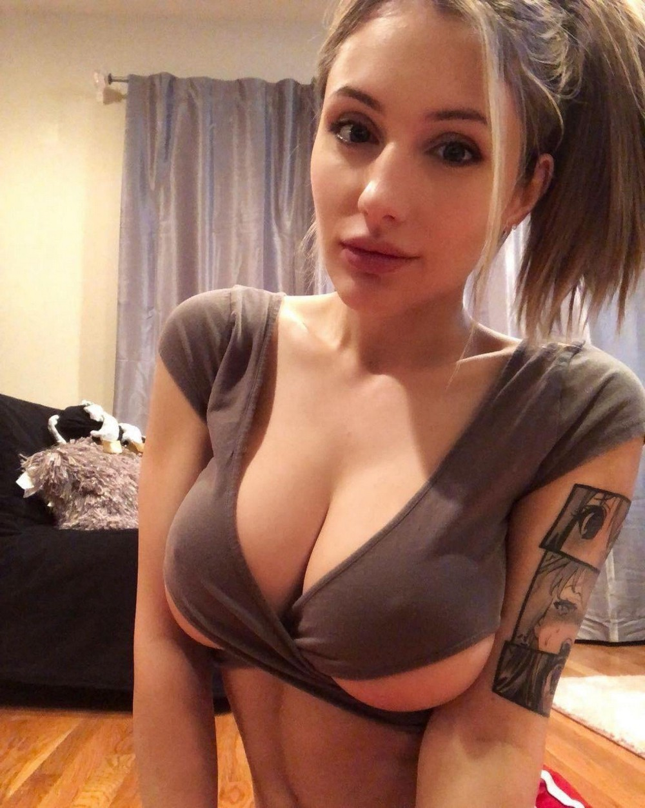

unsubscribe⟹

