My id:86322109765
MY PROFILE NOW
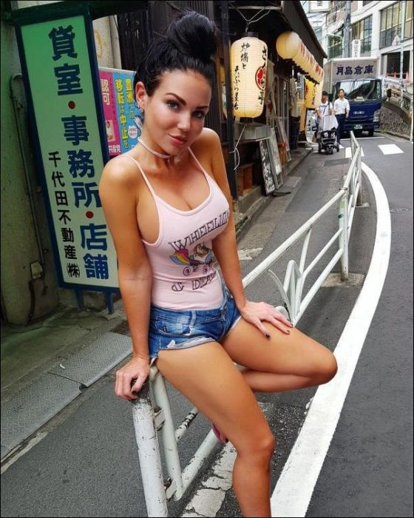
unsubscribe

