Here You Will See All My Body
I Will Show You Myself by web-cam or We can meet!
My name is Sarah
FIND ME BY NICK: bebebody975

VIEW ME ALL
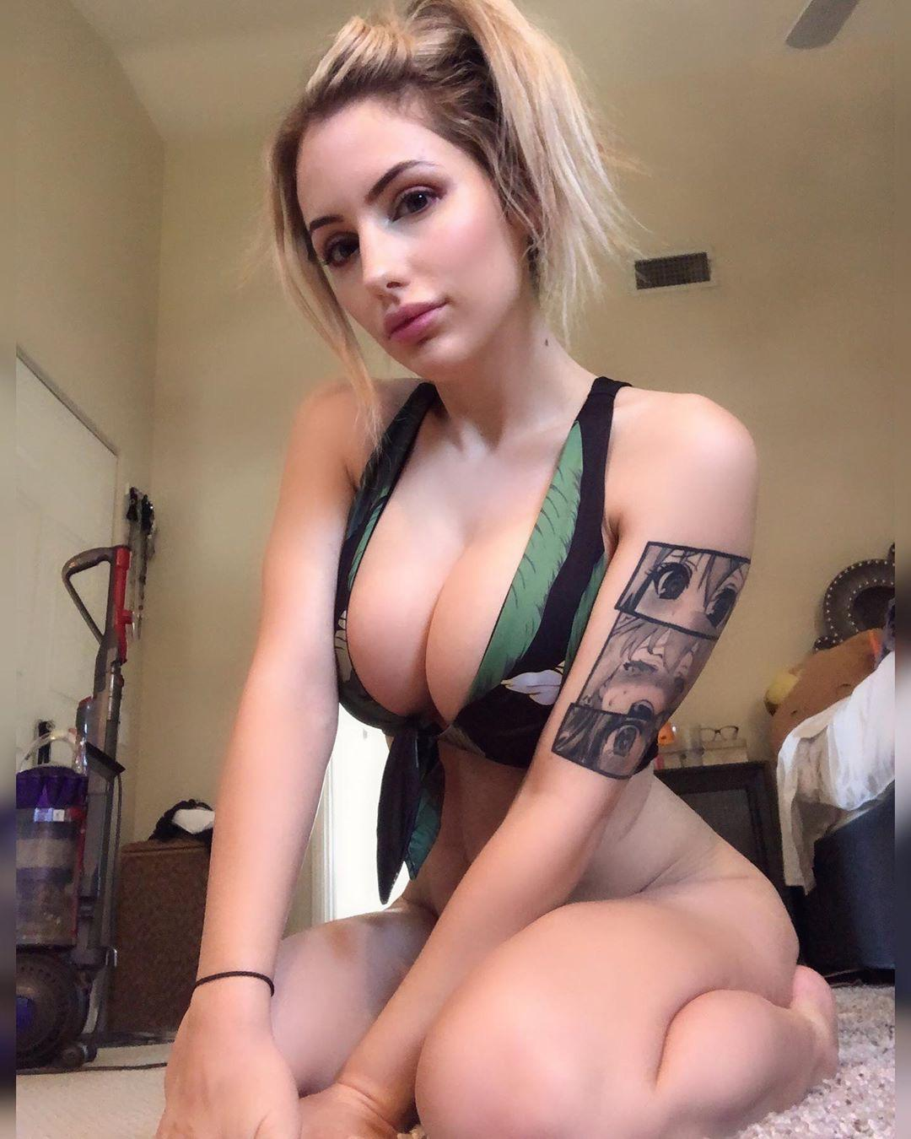
un-s-u-b

