Best Babes Ever
Wanna chat with beauty?
Than I was Made for You, Dear!
My Name on Portal: venera5327723

OPEN NOW
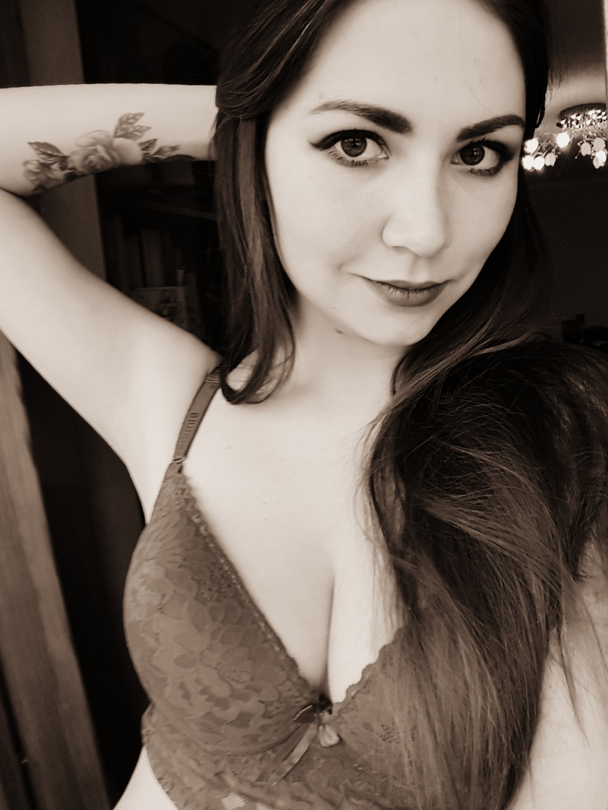
unsub now here

