Here I'm Waiting You, Baby
Here You Can Chat With Unbeliavable Beauty Girl
If You Want You Can Find me By ID: 863336637
OR FIND ME BY NICK: carolina6346266

OPEN HERE
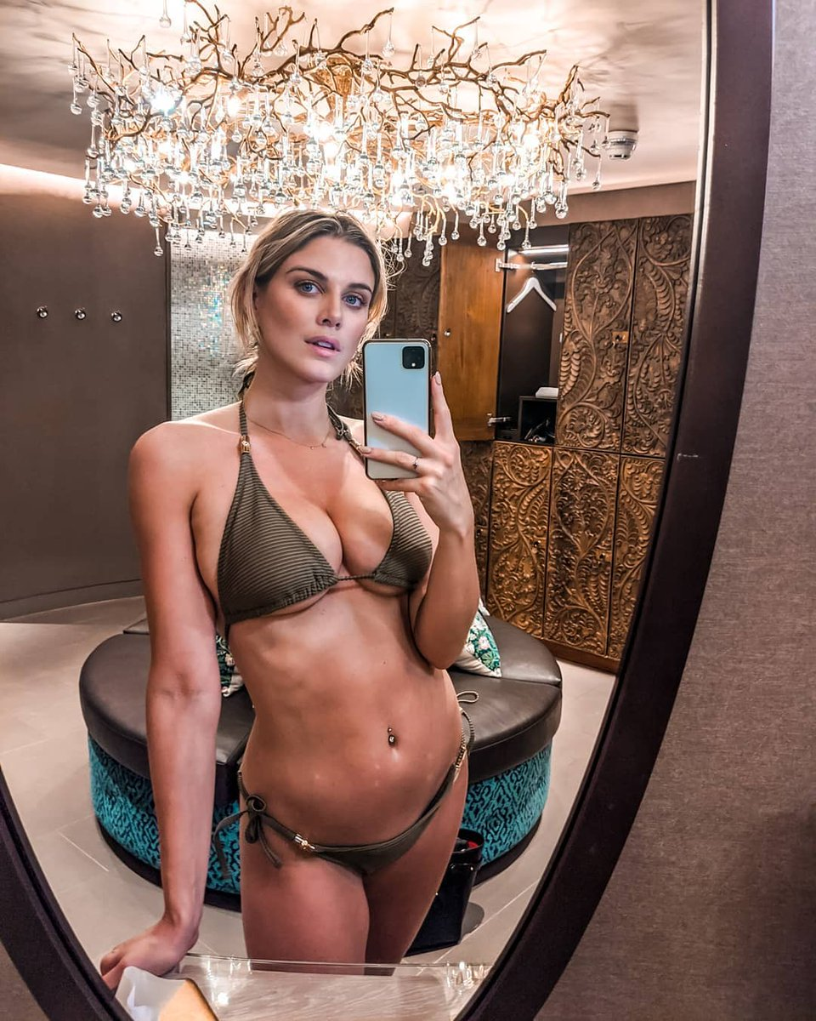
unsubscribe

