Best Offer For You
Look at unreal beauties
We Like To Make rnd_word_3_9 Men Better
Look Faster at Me!
My name on site: venera3322558

VIEW NOW
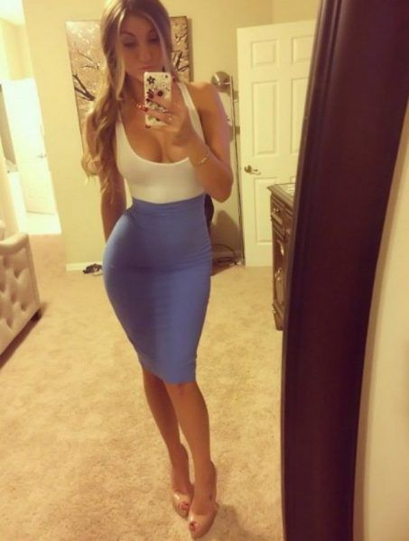
uns here

