😍Here You Can Find Your Love😍
👅You Can Choose and Chat by Web-Cam or Meet👅
👄👄👄Everybody Wanna You Show All Body👄👄👄
My Nick - loretta7318839

CHECK NOW
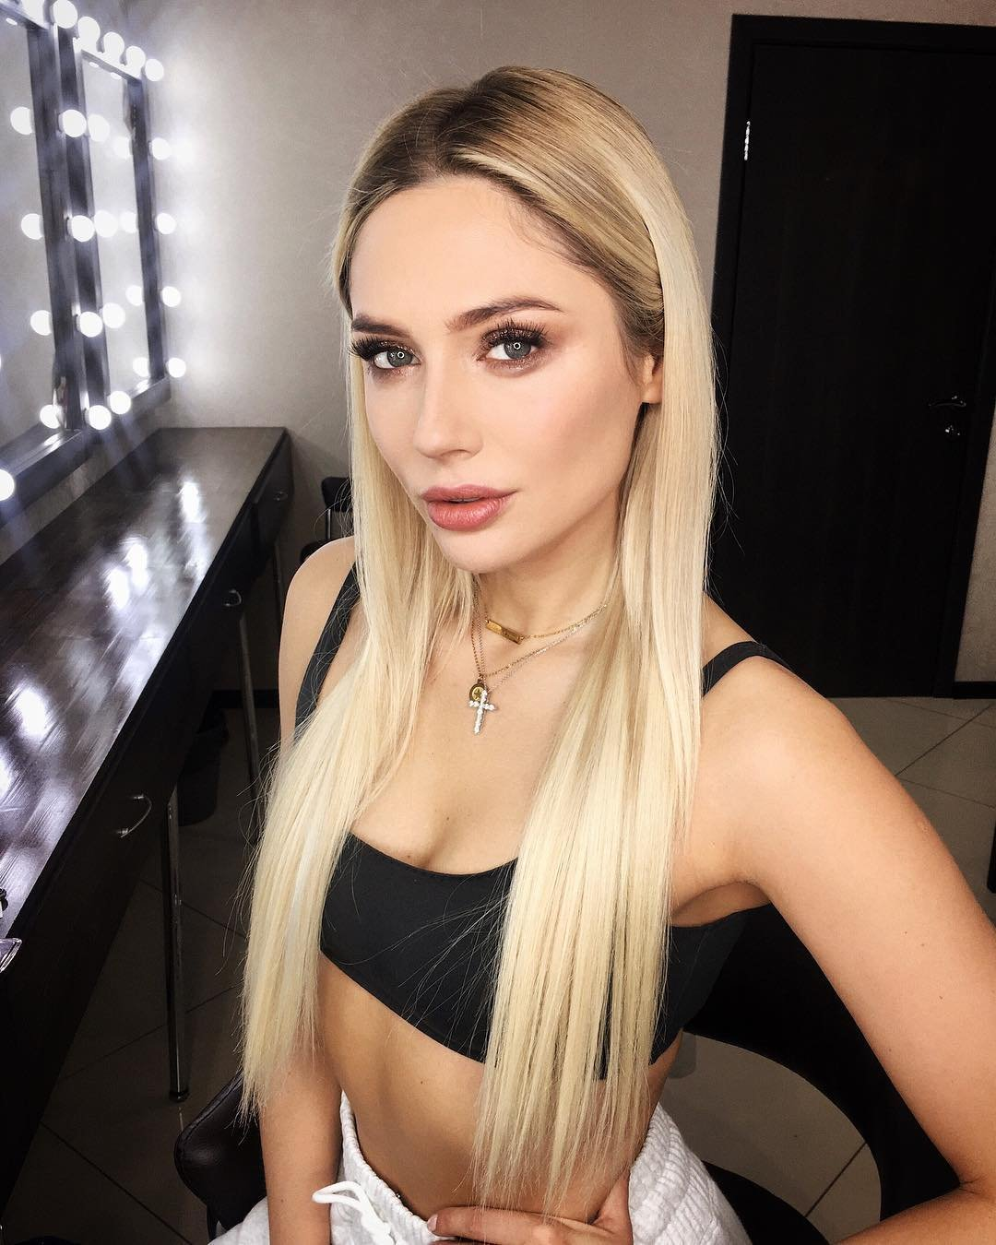
u-n-s-ubscribe

