I Would Like to Chat to Good Man
I'm pretty Slovenian Girl
Nick Name Is - rud8143867

CHECK NOW
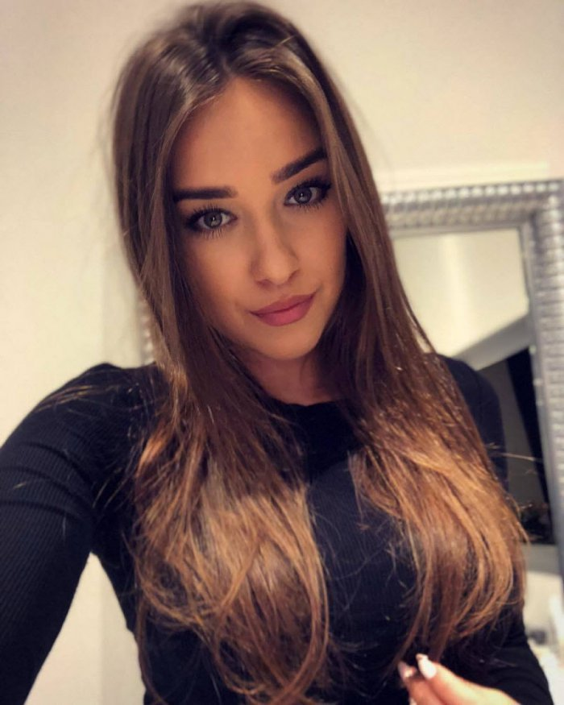
unsub now here

