I Would Like to Chat to Good Man
I'm pretty Slovenian Girl
Nick Name Is - marta6965799

FIND HERE
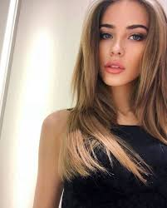
uns here

