I Would Like to Chat to Good Man
I'm pretty Slovenian Girl
Nick Name Is - jiji6163331

FIND NOW
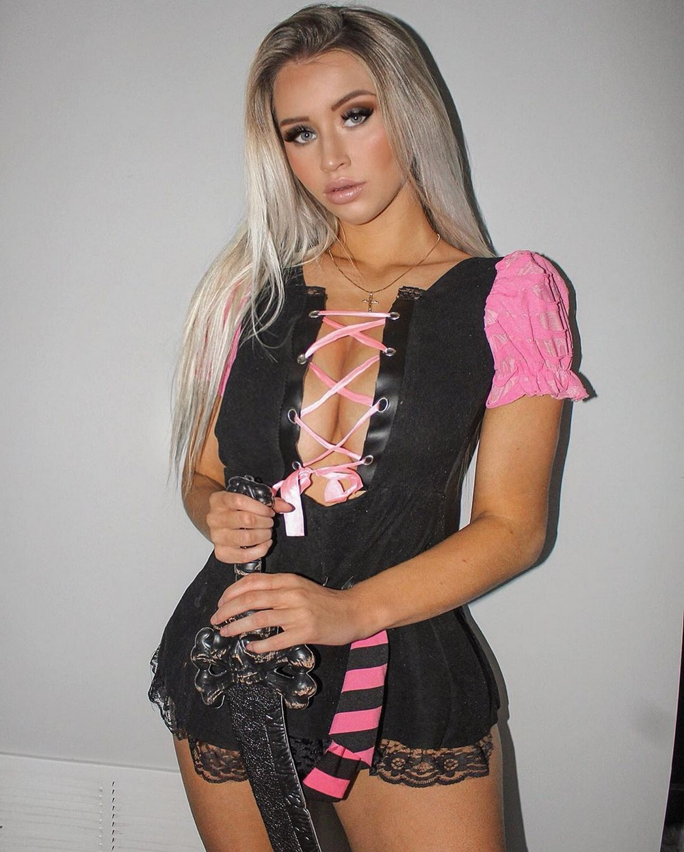
unsub here

