UNBELIEVABLE BEAUTIFUL GIRLS
I WANNA SHOW YOU MY BODY
We Can chat by webcam or meet
FIND ME HERE - marta9462763

OPEN NOW
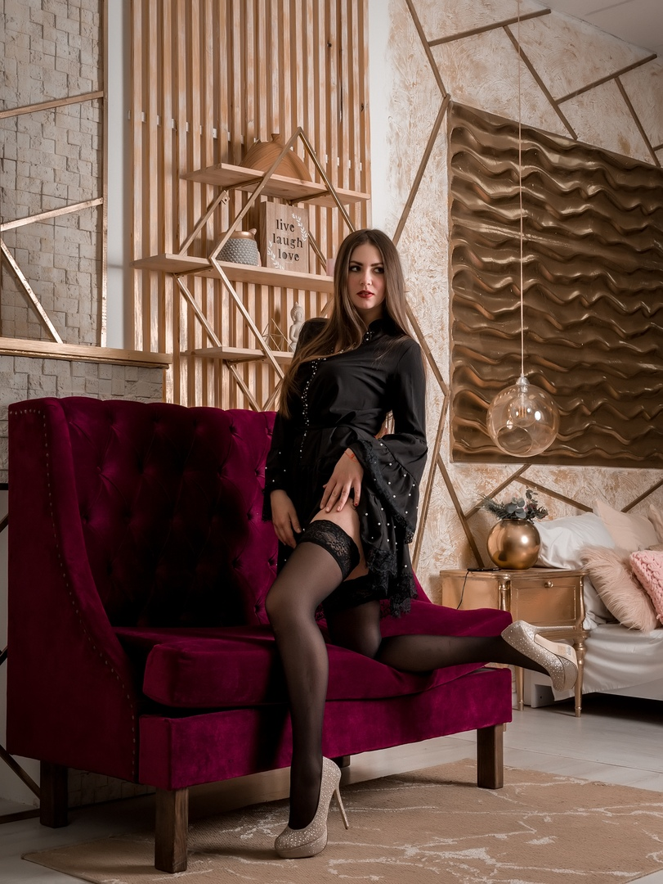
unsub now here

