UNBELIEVABLE BEAUTIFUL GIRLS
I WANNA SHOW YOU MY BODY
We Can chat by webcam or meet
FIND ME HERE - marta8725456

FIND HERE
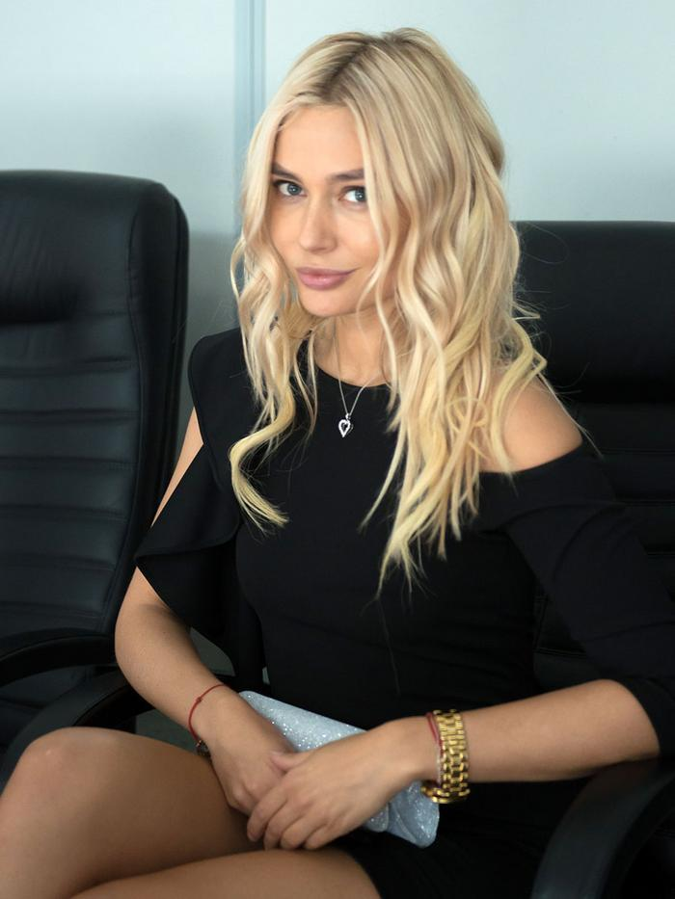
unsub here

