UNBELIEVABLE BEAUTIFUL GIRLS
I WANNA SHOW YOU MY BODY
We Can chat by webcam or meet
FIND ME HERE - roe8621155

CHECK PAGE
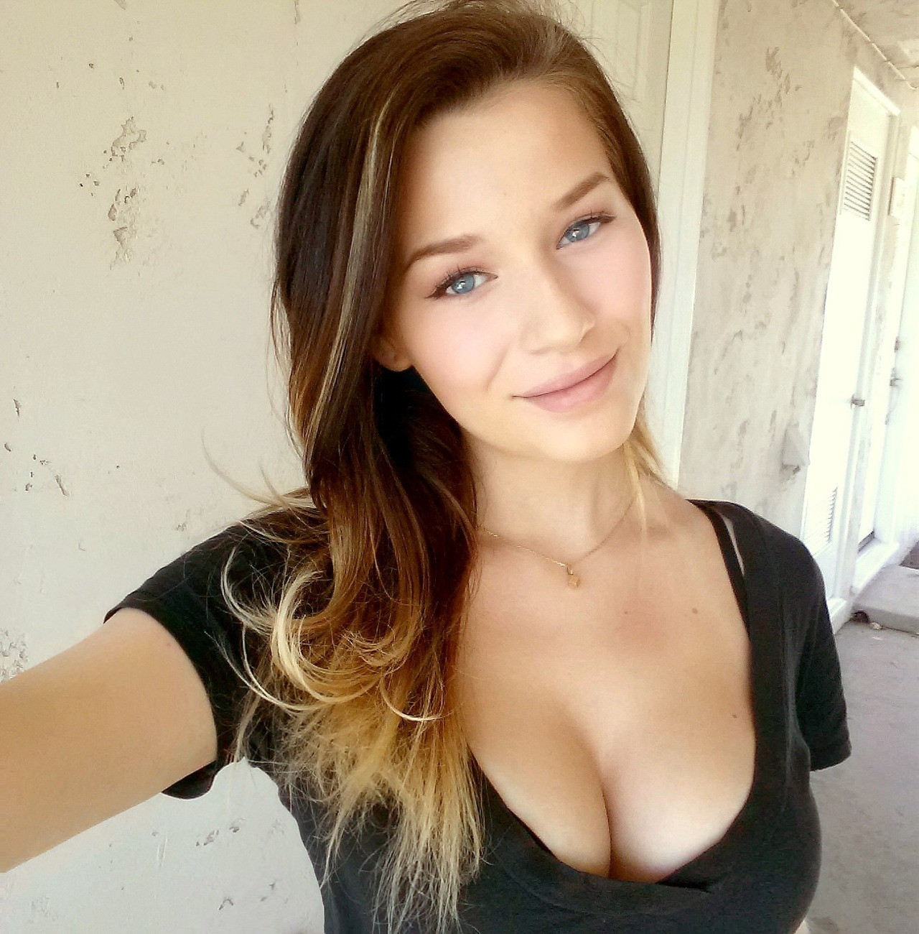
u-n-s-ubscribe

