UNBELIEVABLE BEAUTIFUL GIRLS
I WANNA SHOW YOU MY BODY
Chat To Me NOW!
TRY NOW - marta5195473

OPEN MY PAGE
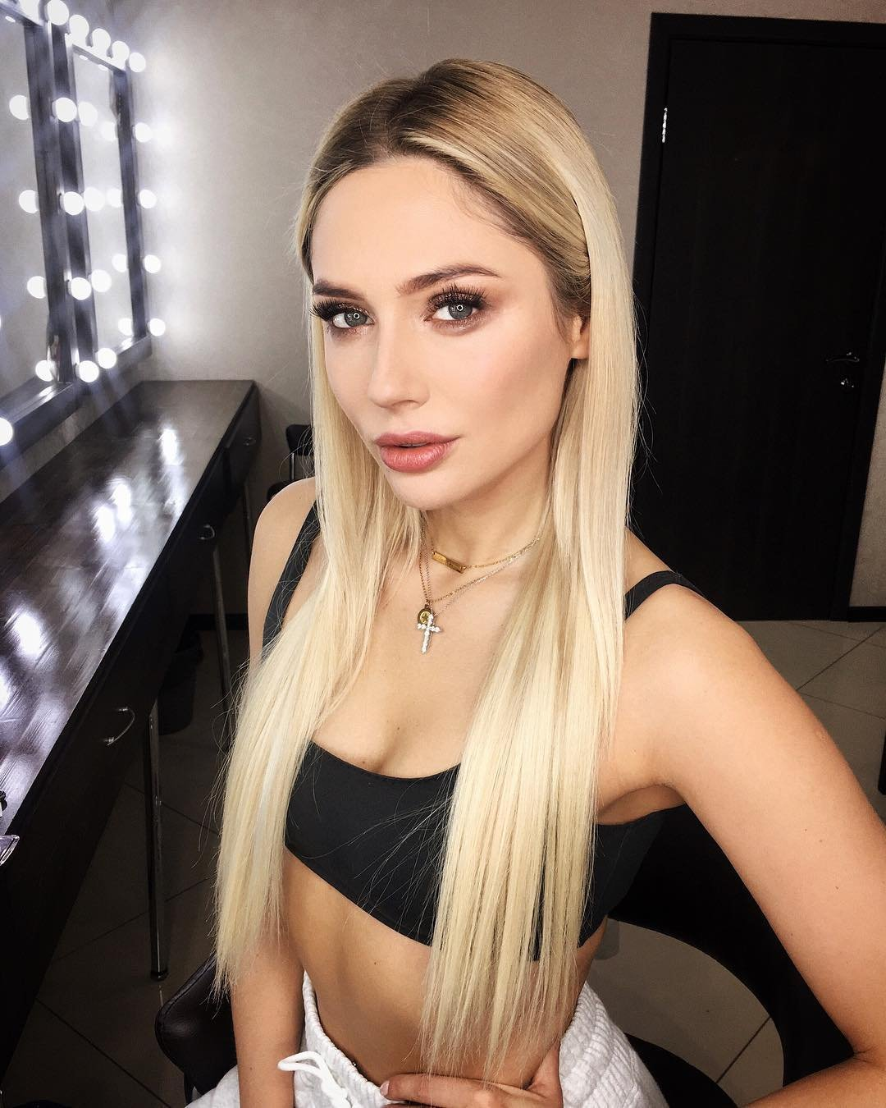
unsubscribe

