UNBELIEVABLE BEAUTIFUL GIRLS
I WANNA SHOW YOU MY BODY
Chat To Me NOW!
TRY NOW - loretta6898511

CHECK MY PAGE
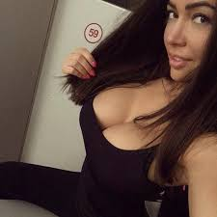
unsub here

