UNBELIEVABLE BEAUTIFUL GIRLS
I WANNA SHOW YOU MY BODY
Chat To Me NOW!
TRY NOW - marta4564279

CHECK PAGE
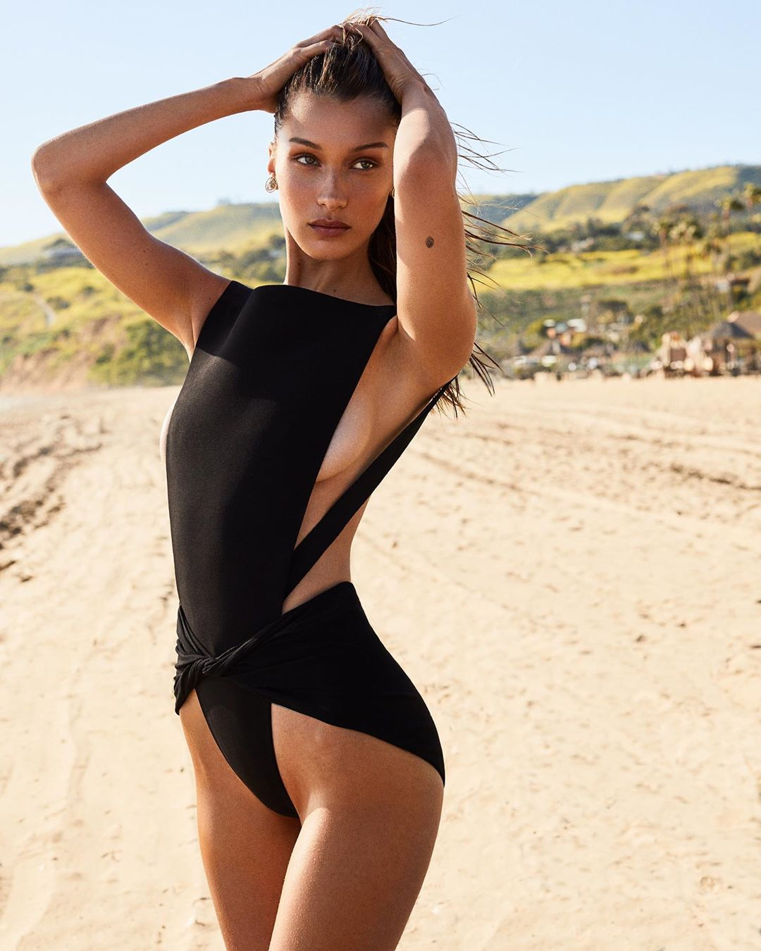
uns here

